Github账户：

516619zhqzh

xiaoxiang516

## General

窗体顶端

Repository name

Rename

窗体底端

窗体顶端

Template repository

Template repositories let users generate new repositories with the same directory structure and files. [Learn more](https://docs.github.com/articles/creating-a-repository-from-a-template/).

窗体底端

窗体顶端

Require contributors to sign off on web-based commits

Enabling this setting will require contributors to sign off on commits made through GitHub’s web interface. Signing off is a way for contributors to affirm that their commit complies with the repository's terms, commonly the [Developer Certificate of Origin (DCO)](https://developercertificate.org/" \t "https://github.com/xiaoxiang516/LearningProcessing/_blank). [Learn more about signing off on commits](https://docs.github.com/en/organizations/managing-organization-settings/managing-the-commit-signoff-policy-for-your-organization" \t "https://github.com/xiaoxiang516/LearningProcessing/_blank).

窗体底端

窗体顶端

## Social Preview

Upload an image to customize your repository’s social media preview.

Images should be at least 640×320px (1280×640px for best display).  
[Download template](https://github.com/xiaoxiang516/LearningProcessing/settings/og-template)

窗体底端

 Edit

## Features

窗体顶端

Wikis

Wikis host documentation for your repository.

Restrict editing to collaborators only

Public wikis will still be readable by everyone.

Issues

Issues integrate lightweight task tracking into your repository. Keep projects on track with issue labels and milestones, and reference them in commit messages.

Sponsorships

Sponsorships help your community know how to financially support this repository.

### Display a "Sponsor" button

Add links to GitHub Sponsors or third-party methods your repository accepts for financial contributions to your project.

[Set up sponsor button](https://github.com/xiaoxiang516/LearningProcessing/new/master?repository_funding=1)

Preserve this repository

Include this code in the [GitHub Archive Program](https://archiveprogram.github.com/faq/).

窗体底端

窗体顶端

Discussions

Discussions is the space for your community to have conversations, ask questions and post answers without opening issues.

窗体底端

### Get started with Discussions

Engage your community by having discussions right in your repository, where your community already lives

窗体顶端

窗体底端

窗体顶端

Projects

Projects on GitHub are created at the repository owner's level (organization or user) and can be linked to a repository's Projects tab. Projects are suitable for cross-repository development efforts such as feature work, complex product roadmaps or even Issue triage.

窗体底端

## Pull Requests

When merging pull requests, you can allow any combination of merge commits, squashing, or rebasing. At least one option must be enabled. If you have linear history requirement enabled on any protected branch, you must enable squashing or rebasing.

窗体顶端

Allow merge commits

Add all commits from the head branch to the base branch with a merge commit.

Default message

Default commit message presented when merging a pull request with merge.

Allow squash merging

Combine all commits from the head branch into a single commit in the base branch.

Default message

Default commit message presented when merging a pull request with squash.

Allow rebase merging

Add all commits from the head branch onto the base branch individually.

Control how and when users are prompted to update their branches if there are new changes available in the base branch.

Always suggest updating pull request branches

Whenever there are new changes available in the base branch, present an “update branch” option in the pull request.

You can allow setting pull requests to merge automatically once all required reviews and status checks have passed.

Allow auto-merge

Waits for merge requirements to be met and then merges automatically. [Learn more](https://docs.github.com/github/collaborating-with-issues-and-pull-requests/automatically-merging-a-pull-request" \t "https://github.com/xiaoxiang516/LearningProcessing/_blank)

After pull requests are merged, you can have head branches deleted automatically.

Automatically delete head branches

Deleted branches will still be able to be restored.

窗体底端

## Archives

When creating source code archives, you can choose to include files stored using Git LFS in the archive.

窗体顶端

Include Git LFS objects in archives

Git LFS usage in archives is billed at the same rate as usage with the client.

窗体底端

## Pushes

窗体顶端

Limit how many branches and tags can be updated in a single push Beta

Pushes will be rejected if they attempt to update more than this. [Learn more](https://github.blog/changelog/2022-06-15-block-potentially-destructive-git-pushes) about this setting, and send us your [feedback](https://github.com/github-community/community/discussions/categories/general).

窗体底端

## Danger Zone

Change visibility

**Change repository visibility**

For security reasons, you cannot change the visibility of a fork.

**Transfer ownership**

Transfer this repository to another user or to an organization where you have the ability to create repositories.

* [Transfer](https://github.com/xiaoxiang516/LearningProcessing/transfer)
* Archive this repository

**Archive this repository**

Mark this repository as archived and read-only.

* Delete this repository

**Delete this repository**

Once you delete a repository, there is no going back. Please be certain.

### Really change your username?

 Unexpected bad things will happen if you don’t read this!

* We **will not** set up redirects for your old profile page.
* We **will not** set up redirects for Pages sites.
* We **will** create redirects for your repositories (web and git access).
* Renaming may take a few minutes to complete.

阮一峰 说：

本文关闭留言功能。

遇到问题的网友，可以参考以下网址。

- 我的实例库: <https://github.com/ruanyf/jekyll_demo>

- 发明者mojombo的实例库：<https://github.com/mojombo/mojombo.github.io>

- 官方网站：[http://jekyllrb.com/](https://jekyllrb.com/)

# 博客园

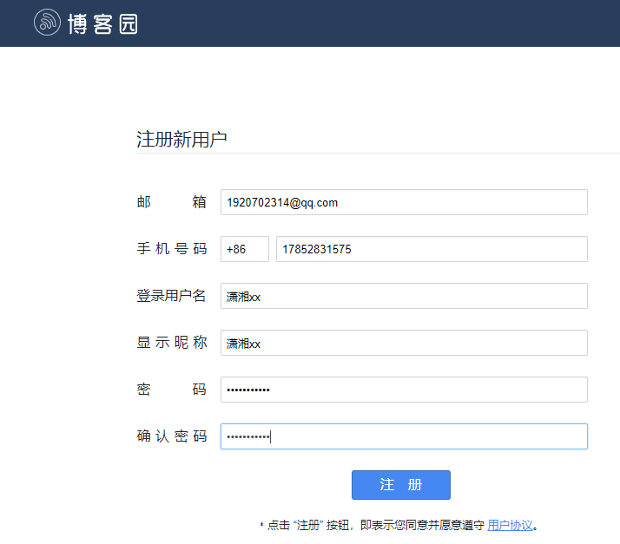

**操作github步骤**

**01上传文件**

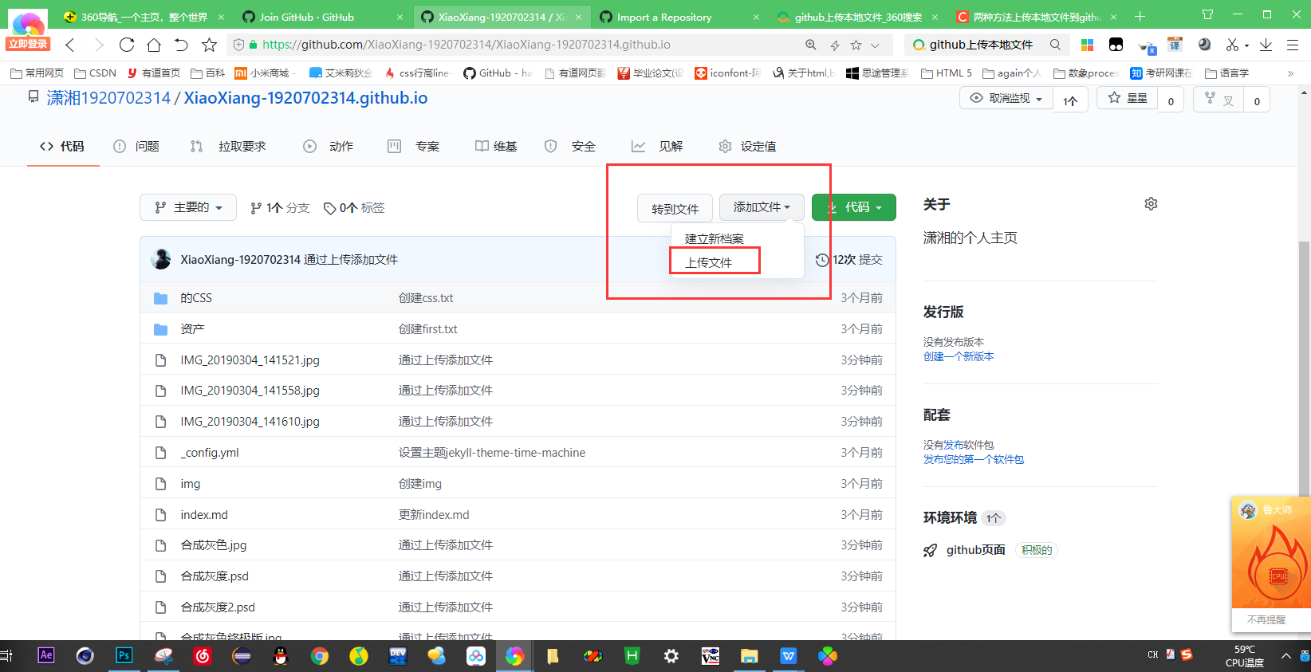

**01.进入自己的主页**

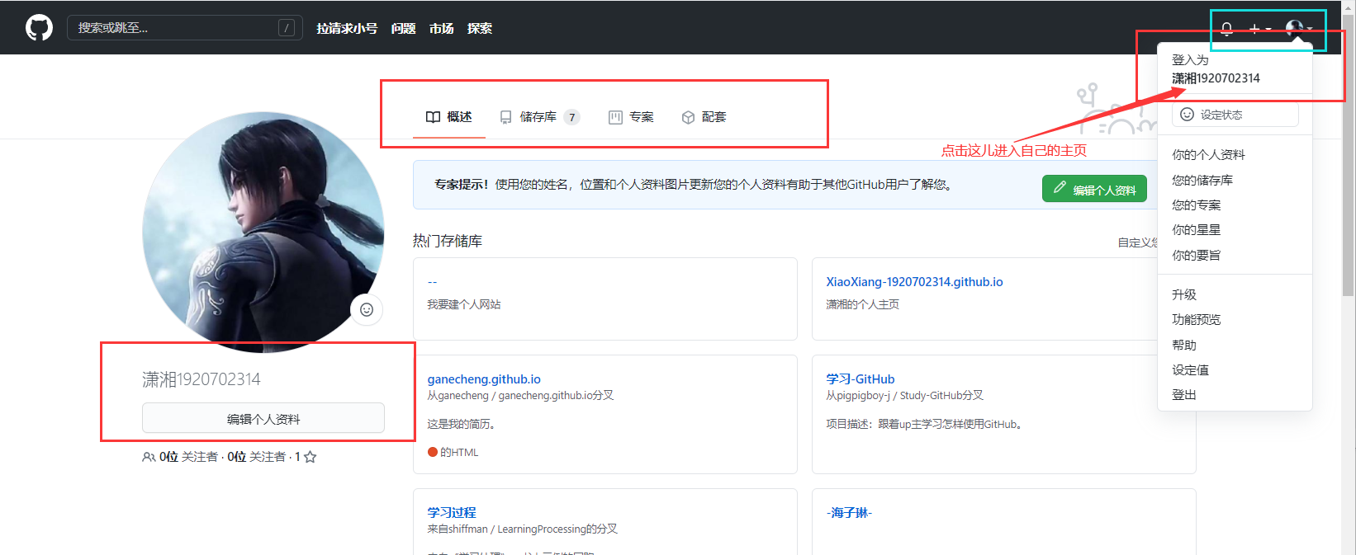

03修改用户名

<https://blog.csdn.net/qq_36667170/article/details/79067306>

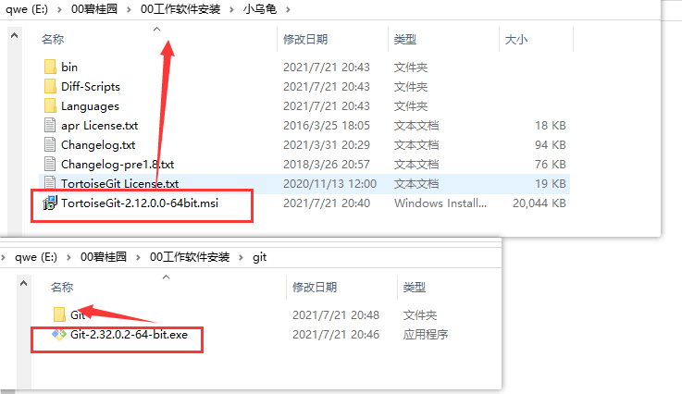

**Git的安装步骤**

Git clone出错

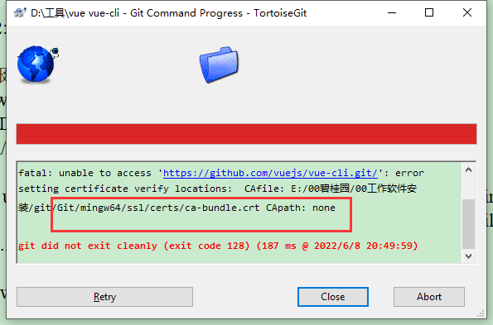

运行npm时git报错ca-bundle.crt CApath: none的处理

运行npm时候报错，git的报错：

npm ERR! Error while executing:

npm ERR! D:\RDC\Git\Git-2.30.2-64-bit\cmd\git.EXE ls-remote -h -t https://github.com/nhn/raphael.git

npm ERR!

npm ERR! fatal: unable to access 'https://github.com/nhn/raphael.git/': error setting certificate verify locations: CAfile: D:\RDC\Git\Git-2.30.2-64-bit\bin\curl-ca-bundle.crt CApath: none

npm ERR!

npm ERR! exited with error code: 128

解决方式有两种:

1.在git bash窗口里面

执行命令：

git config --system http.sslcainfo

"D:\RDC\Git\Git-2.30.2-64-bit\mingw64\ssl\certs\ca-bundle.crt"

1

注意修改为正确的文件路径

**2.注意：忽略ssl认证**

git config --system http.sslverify false

————————————————

版权声明：本文为CSDN博主「行者张良」的原创文章，遵循CC 4.0 BY-SA版权协议，转载请附上原文出处链接及本声明。

原文链接：https://blog.csdn.net/hualinger/article/details/114973868

* 在cmd中输入git命令提示‘git‘ 不是内部或外部命令，也不是可运行的程序 或批处理文件。

解决方法

一：找到安装git目录下的bin目录，复制这个目录

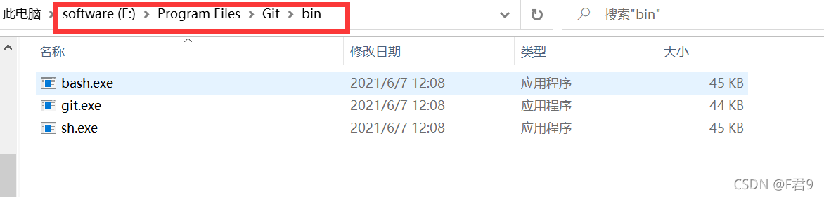

如果不知道自己把git安装在哪儿了，可以打开git bash客户端，输入where git即可

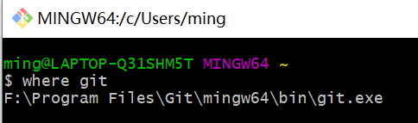

二：将复制好目录添加到系统变量Path中

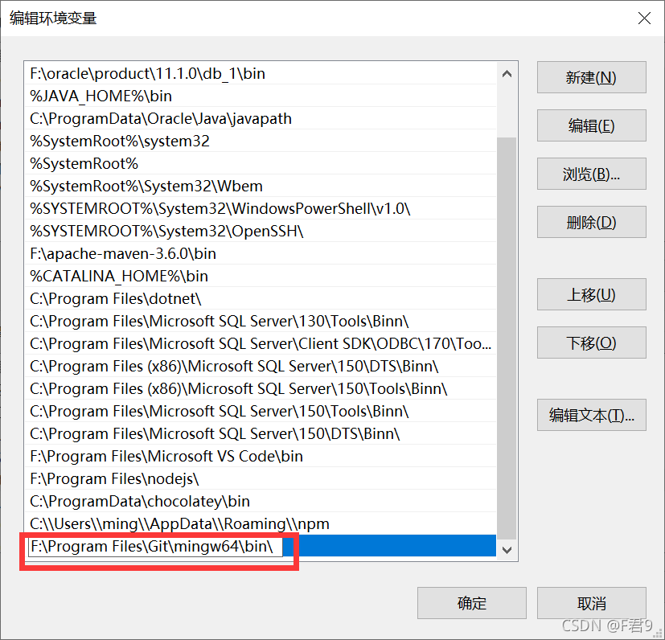

**三：重新打开cmd，大功告成~**

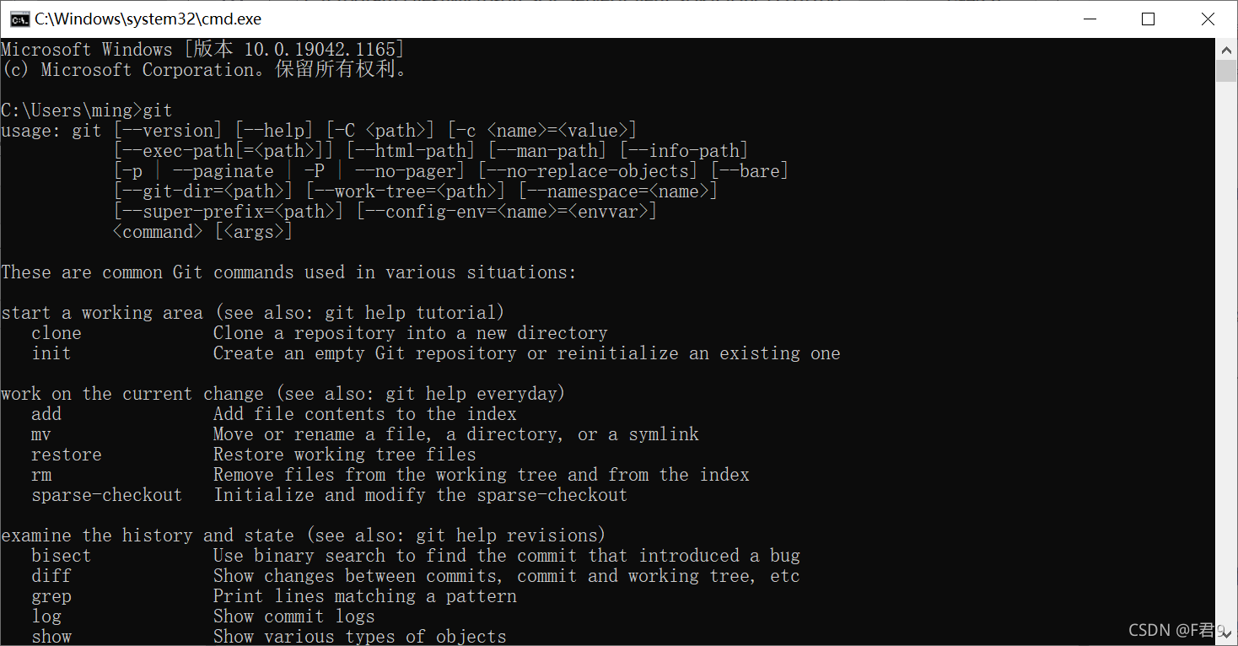

**gitee.com**

# 提交空文件

git设计时是不支持空文件夹提交的，这里是在文件夹里面新建.gitignore文件或者.gitkeep空文件来处理的

unity也支持忽略以.开头的文件的

新建.gitignore文件

在空文件夹下新建.gitignore文件，文件内容：

# Ignore everything in this directory

\*

# Except this file

!.gitignore

这样就能提交git仓库了

我这是在windows上操作的，不能直接创建以.开头的文件，参考这篇文章Windows创建.开头的文件或者.开头的文件夹

新建.gitkeep文件

在空文件夹下新建.gitkeep文件，是空文件，这样就能提交git仓库了

————————————————

版权声明：本文为CSDN博主「 codingriver 」的原创文章，遵循CC 4.0 BY-SA版权协议，转载请附上原文出处链接及本声明。

原文链接：https://blog.csdn.net/codingriver/article/details/83414795

### 增删查改

```

1.新建git仓库： git init  路径（git init D:/GIT/resposity）

2.新建用户名： git config --global user.name 用户名（ git config --global user.name array）

3.新建邮箱： git config --global user.name 邮箱

4.新增用户： git config --global --add user.name 用户名

5.查询用户： git config user.name

                        git config --get user.name

  6.获取所有用户信息： git config --list --global

7.删除用户：git config --global --unset user.name object

8.git 别名：git config --global alias.以前的变量   别名

                       git config --global alias.commit ct

9.提示快捷键  ：双击tab（比如打出conf然后双击tab会自动补全为config）

————————————————

版权声明：本文为CSDN博主「小蒋小蒋快乐成长」的原创文章，遵循CC 4.0 BY-SA版权协议，转载请附上原文出处链接及本声明。

原文链接：https://blog.csdn.net/object\_oriented/article/details/82385733

```

## FAQ

git.exe clone --progress --recursive -v "https://gitee.com/xiaoxiang516/component-library.git" "D:\elementui\component-library"

Cloning into 'D:\elementui\component-library'...

remote: [session-ad45e7aa] xiaoxiang516: Incorrect username or password (access token)

fatal: Authentication failed for 'https://gitee.com/xiaoxiang516/component-library.git/'

git did not exit cleanly (exit code 128) (23969 ms @ 2022/7/2 18:31:59)

## 2.登录认证：用户名与密码

成功git.exe clone --progress --recursive -v "https://gitee.com/xiaoxiang516/component-library.git" "D:\elementui\component-library"

Cloning into 'D:\elementui\component-library'...

POST git-upload-pack (185 bytes)

POST git-upload-pack (212 bytes)

remote: Enumerating objects: 6, done.

remote: Counting objects: 100% (6/6), done.

remote: Compressing objects: 100% (5/5), done.

remote: Total 6 (delta 0), reused 0 (delta 0), pack-reused 0

Receiving objects: 100% (6/6), done.

Success (47984 ms @ 2022/7/2 18:36:24)

3.

[Github官网跳转链接](https://github.com/)

<https://github.com/>

Username may only contain alphanumeric characters or single hyphens,

用户名只能包含字母、数字字符或单个连字符

**[Git下载](https://gitforwindows.org/)**



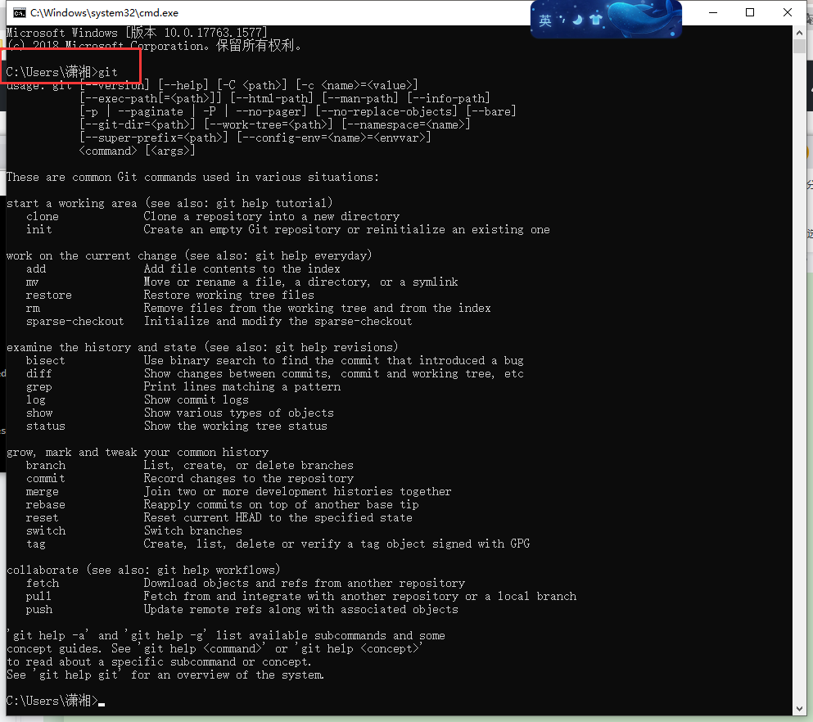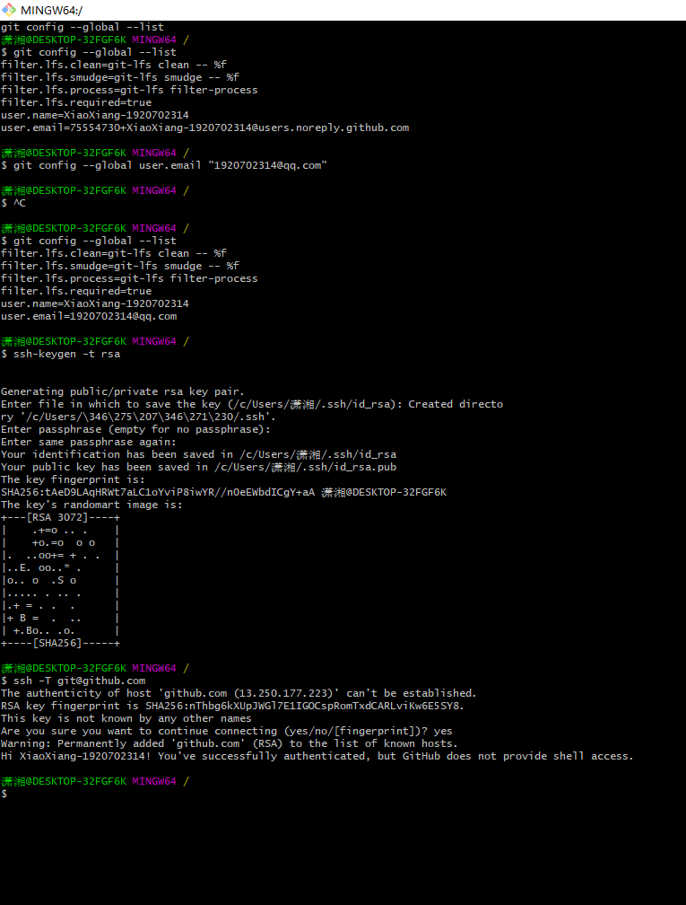

**[小乌龟下载](https://tortoisegit.org/download/)**

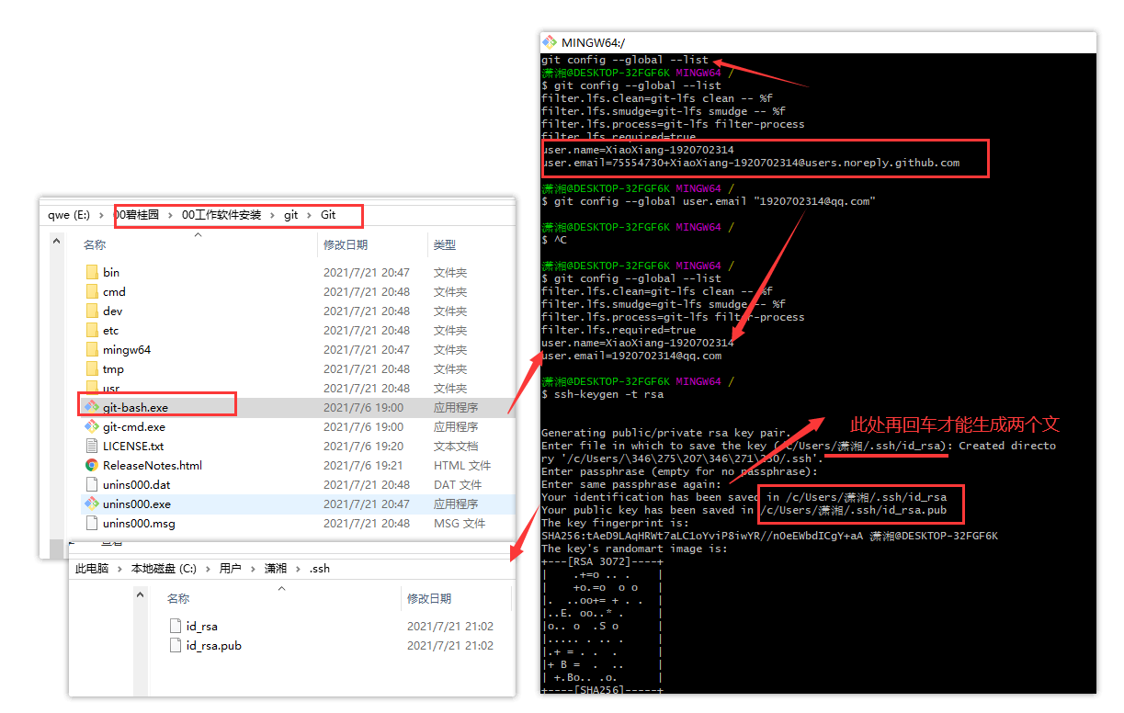

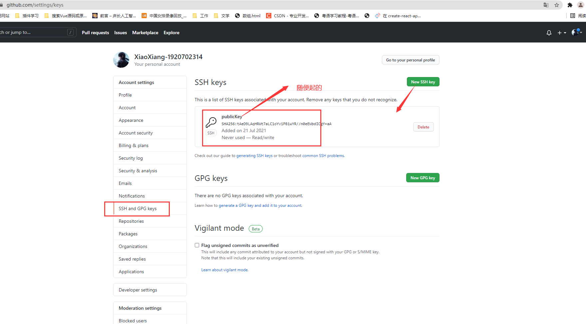

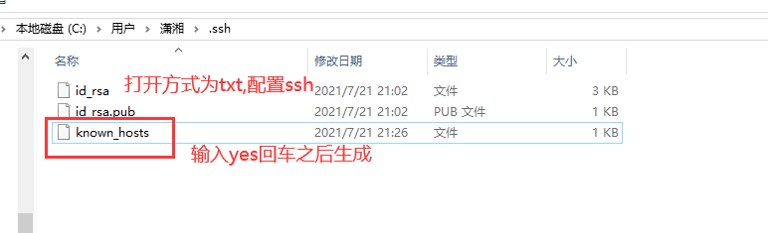

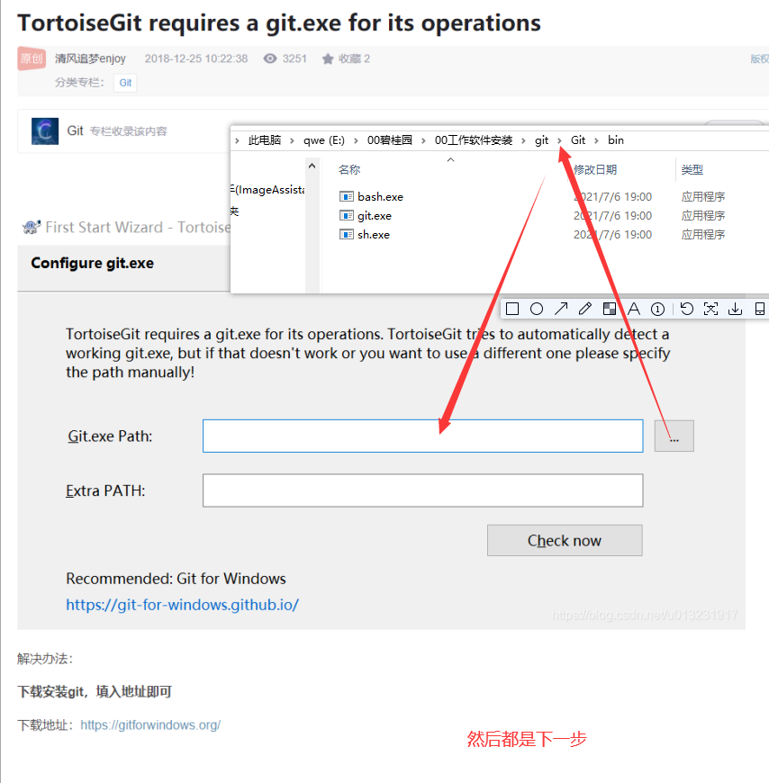

### ****Quick setup**** — if you’ve done this kind of thing before

[Set up in Desktop](x-github-client://openRepo/https://github.com/xiaoxiang516/learn-typescript)

**or**

窗体顶端

HTTPS

窗体底端

窗体顶端

SSH

窗体底端

Get started by [creating a new file](https://github.com/xiaoxiang516/learn-typescript/new/main) or [uploading an existing file](https://github.com/xiaoxiang516/learn-typescript/upload). We recommend every repository include a [README](https://github.com/xiaoxiang516/learn-typescript/new/main?readme=1), [LICENSE](https://github.com/xiaoxiang516/learn-typescript/new/main?filename=LICENSE.md), and [.gitignore](https://github.com/xiaoxiang516/learn-typescript/new/main?filename=.gitignore).

### …or create a new repository on the command line

echo "# learn-typescript" >> README.mdgit initgit add README.mdgit commit -m "first commit"git branch -M maingit remote add origin https://github.com/xiaoxiang516/learn-typescript.gitgit push -u origin main

### …or push an existing repository from the command line

git remote add origin https://github.com/xiaoxiang516/learn-typescript.gitgit branch -M maingit push -u origin main

### …or import code from another repository

You can initialize this repository with code from a Subversion, Mercurial, or TFS project.

[Import code](https://github.com/xiaoxiang516/learn-typescript/import)

# **如何生成SSH公钥私钥?**

[](https://www.jianshu.com/u/b7a6e45eba54)

[哒哒哒哒da](https://www.jianshu.com/u/b7a6e45eba54" \t "https://www.jianshu.com/p/_blank)关注IP属地: 广东

0.0642019.03.13 11:55:49字数 434阅读 13,533

在装了git的情况下,先查看在C:\Users\win10文件夹下是否有一个.ssh文件夹,里面有3个文件(一般是这个地址)



如果找不到的话,可以通过以命令查看:



在弹出窗口中输入cd ~/.ssh,然后输入ls查看秘钥列表



如上图是已经配置过了就无需配置。如果没有看到id\_ras.pub文件即没有配置，然后请看下面如何配置

你可以按如下命令来生成 ssh key:

**ssh-keygen -t rsa -C "xxxxx@xxxxx.com"**

按三次回车你就会看见这个东西(不要在意为什么生成的不一样,这里生成的中文是我自己写的)



#### **注意:生成的文件名跟密码可以不填,直接按3次回车.填了以后使用git都要输入密码,就显得很麻烦,那还不如不填.**

按照提示完成三次回车，即可生成 ssh key.通过查看 ~/.ssh/id\_rsa.pub 文件内容，获取到你的ssh key

**cat ~/.ssh/id\_rsa.pub**

输出:



这个就是ssh key的内容(可以理解公钥)

复制生成后的 ssh key，通过**点击个人头下的设置>找到安全设置>SSH公钥** ，添加生成的ssh key 添加到仓库中。(这个以码云为例)





添加后，在终端中输入

**ssh -T git@gitee.com**

首次使用需要确认并添加主机到本机SSH可信列表。若返回 Hi XXX! You've successfully authenticated, but Gitee.com does not provide shell access. 内容，则证明添加成功。

添加成功后，就可以使用SSH协议对仓库进行操作了。

3人点赞

[配置(cmd,ssh,webstrom)](https://www.jianshu.com/nb/35056784" \t "https://www.jianshu.com/p/_blank)

C:\Users\zhuqizhong\.ssh

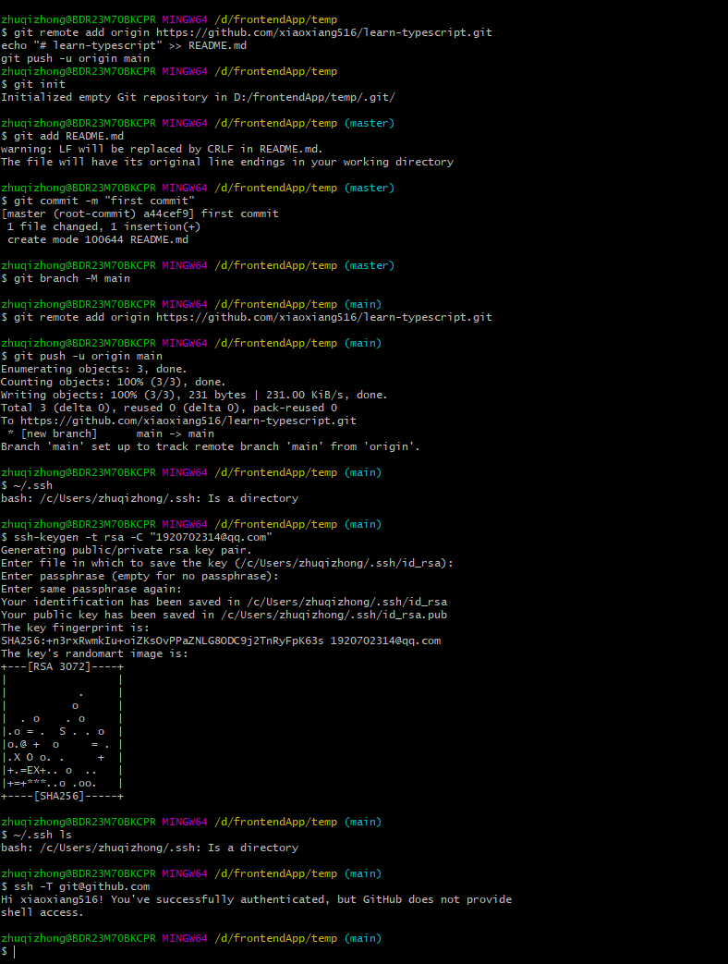

**sh deploy.sh 报错**

#!/usr/bin/env sh

# 确保脚本抛出遇到的错误

set -e

# 生成静态文件

npm run docs:build

# 进入生成的文件夹

cd docs/.vuepress/dist

git init

git add -A

git commit -m 'deploy'

# 如果发布到 https://<USERNAME>.github.io/<REPO>

git push -f git@github.com:xiaoxiang516/learn-typescript.git master:gh-pages

cd -

[git提示 permission denied (publickey)问题的解决方法](https://lolitasian.blog.csdn.net/article/details/100894172?spm=1001.2101.3001.6661.1&utm_medium=distribute.pc_relevant_t0.none-task-blog-2%7Edefault%7ECTRLIST%7ERate-1-100894172-blog-52598863.pc_relevant_3mothn_strategy_recovery&depth_1-utm_source=distribu)

[LolitaAnn](https://lolitasian.blog.csdn.net/" \o "LolitaAnn" \t "_blank) IMG_261于 2019-09-16 17:28:22 发布 IMG_26249065 IMG_263IMG_264收藏 38

分类专栏： [Git](https://blog.csdn.net/qq_36667170/category_7402630.html" \t "_blank)

本文为博主原创文章，未经博主允许不得转载。

本文链接：[https://blog.csdn.net/qq\_36667170/article/details/100894172](https://blog.csdn.net/qq_36667170/article/details/100894172" \t "_blank)

版权

好久没用git了，由于我前几天失误手抖把我项目删光了之后，我有重新开始用了……却发现我远程仓库？？？为什么传不上去！！！为什么报错！！！(｡•́︿•̀｡)  
我以为[github](https://so.csdn.net/so/search?q=github&spm=1001.2101.3001.7020" \t "_blank)出问题了，然后我又试了一下gitee和coding，都这样……当然了，本仙女这么机智肯定找到了解决办法(\*‘▽’\*)♪

出现的问题（解决方法往后看）

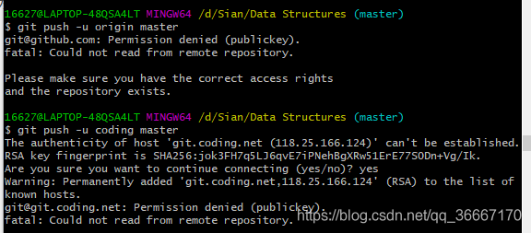  
**Github** 显示：

git@github.com: Permission denied (publickey).  
fatal: Could not read from remote repository.  
Please make sure you have the correct access rights  
and the repository exists.

**coding** 显示：

The authenticity of host ‘git.coding.net (118.25.166.124)’ can’t be established.  
RSA key fingerprint is SHA256:jok3FH7q5LJ6qvE7iPNehBgXRw51ErE77S0Dn+Vg/Ik.  
Are you sure you want to continue connecting (yes/no)? yes  
Warning: Permanently added ‘git.coding.net,118.25.166.124’ (RSA) to the list of known hosts.  
git@git.coding.net: Permission denied (publickey).  
fatal: Could not read from remote repository.

解决方法

最后搞来搞去是我太久没用了。我的SSH实效了，需要重新配置。

首先检查一下你电脑上SSH还在不在吧

gitbash输入ls ~/.ssh/  
进行检查 id\_rsa.pub 是否存在，如果存在，就不用生成一个新的SSH key了，继续往下看就OK了。**如果不在，那就重新配置吧**，[SSH配置（github、coding、gitee都适用）](https://blog.csdn.net/qq_36667170/article/details/79094257)  
看了一下，我的还在，你输入命令行，如果在的话会出现文件名。  
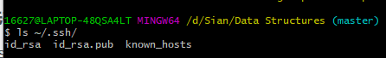

如果电脑上SSH

上边显示了我的SSH文件叫id\_rsa.pub，去找这个文件，一般来说都在C:/user/用户名/.ssh文件夹下，找到之后用记事本打开**id\_rsa.pub**，然后全选里面的东西复制。  
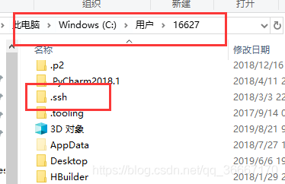  
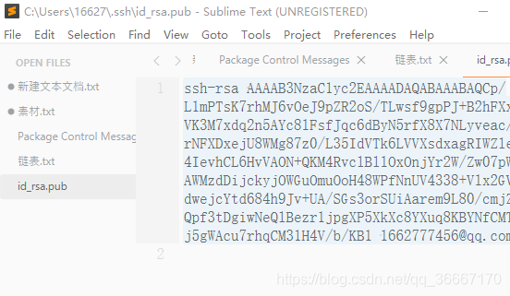  
转到github，用户设置那里找到SSH and GPG keys，点击新建，把你复制的粘贴进key那里，title随便填，不填也行，然后点击添加就OK。之后你就会收到成功添加的邮件。[gitee](https://so.csdn.net/so/search?q=gitee&spm=1001.2101.3001.7020" \t "_blank)、coding同理。  
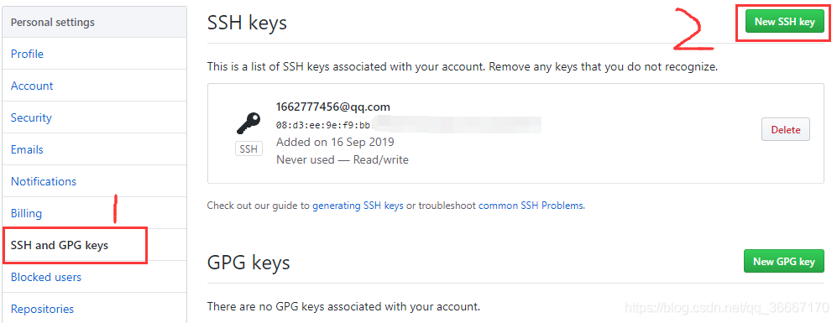  
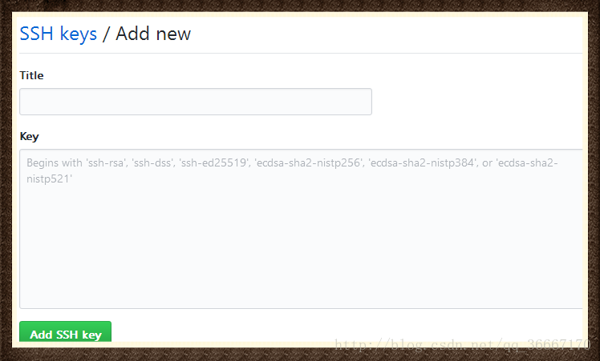  


我是Sian，我还是不想放弃做程序媛。加油吧。

[写文章](https://mp.csdn.net/edit" \t "_blank)

* [发动态](https://blink.csdn.net/" \t "_blank)
* [提问题](https://ask.csdn.net/new?utm_source=p_toolbar" \t "_blank)
* [传资源](https://mp.csdn.net/mp_download/creation/uploadResources" \t "_blank)
* [建项目](https://gitcode.net/explore" \t "_blank)

创作活动[更多](https://mp.csdn.net/mp_blog/manage/creative?spm=1011.2124.3001.5311" \t "_blank)

* [#2月征文活动来喽](https://bbs.csdn.net/topics/613510158" \t "_blank)
* [#「文库超级创作者计划」开启，招募宝藏作者](https://marketing.csdn.net/p/3b6c6473d7ac50bc29aef30033d4a07f?utm_source=czzx_hd" \t "_blank)

[Git教程 SSH keys配置](https://lolitasian.blog.csdn.net/article/details/79318578)

[LolitaAnn](https://lolitasian.blog.csdn.net/" \o "LolitaAnn" \t "_blank) IMG_261于 2018-01-18 11:42:40 发布 IMG_26279479 IMG_263IMG_264收藏 587

分类专栏： [Git](https://blog.csdn.net/qq_36667170/category_7402630.html" \t "_blank) 文章标签： [ssh](https://so.csdn.net/so/search/s.do?q=ssh&t=all&o=vip&s=&l=&f=&viparticle=" \t "_blank) [git](https://so.csdn.net/so/search/s.do?q=git&t=all&o=vip&s=&l=&f=&viparticle=" \t "_blank) [运维](https://so.csdn.net/so/search/s.do?q=%E8%BF%90%E7%BB%B4&t=all&o=vip&s=&l=&f=&viparticle=" \t "_blank)

本文为博主原创文章，未经博主允许不得转载。

本文链接：[https://blog.csdn.net/qq\_36667170/article/details/79094257](https://blog.csdn.net/qq_36667170/article/details/79094257" \t "_blank)

版权

21 篇文章 45 订阅

订阅专栏

SSH 为 Secure Shell 的缩写，由 IETF 的网络小组（Network Working Group）所制定；SSH 为建立在应用层基础上的安全协议。

这个不止适用于[github](https://so.csdn.net/so/search?q=github&spm=1001.2101.3001.7020" \t "_blank)。像gitee、coding等等都可以用。

在管理Git项目上，有两种克隆到本地的方法。

* 直接使用https url克隆到本地
* 使用SSH url克隆到本地

**这两种方式的主要区别在于**：

* 使用https url对初学者来说会比较方便，复制https url然后到git Bash里面直接用clone命令克隆到本地就好了，但是每次fetch和push代码都需要输入账号和密码，这也是https方式的麻烦之处。
* 使用SSH url需要在只用之前先配置和添加好SSH key。每次fetch和push代码都不需要输入账号和密码，如果你想要每次都输入账号密码才能进行fetch和push也可以另外进行设置。

1.检查你电脑上是否有SSH Key

~/.ssh 或者用~/.ssh ls

上边这行命令的作用是看一哈你的电脑上有没有.ssh文件夹。

* 如果电脑上**有**，就会显示**bash: /c/Users/…/.ssh: Is a directory**
* 如果电脑上**没有**，那就显示**bash: /c/Users/…/.ssh: No such file or directory**

IMG_266  
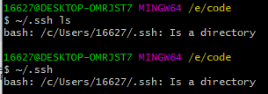

2.创建SSH Key

**如果你电脑上有了，你就可以直接跳过这一步**

在Git Bash中输入  
$ ssh-keygen -t rsa -C "你的邮箱"  
IMG_268

然后就会显示这两行：  
**Generating public/private rsa key pair.  
Enter file in which to save the key (/c/Users/16627/.ssh/id\_rsa):**

这是让你输入一个文件名，用于保存刚才生成的 SSH key 代码。为了避免麻烦，不用输入，直接回车，那么就会默认生成id\_rsa和id\_rsa.pub两个秘钥文件。  
这时候已经创建好.ssh这个文件夹了，会提示：  
**Created directory ‘/c/Users/16627/.ssh’.**  
紧接着又会问你：  
**Enter passphrase (empty for no passphrase):**  
就是让你输入密码，如果你设置了密码，那在你使用ssh传输文件的时候，你就要输入这个密码。为了避免麻烦，建议不用设置，直接回车。  
**Enter same passphrase again:**  
这就是让你再输入一次密码，就跟我们注册账号时候设置密码需要设置两次一样。上一步没设置密码，这里直接回车就可以了。到这里你的秘钥就设置好了，你会收到这段代码提示：  
**Your identification has been saved in /c/Users/…/.ssh/id\_rsa  
Your public key has been saved in /c/Users/…/.ssh/id\_rsa.pub**  
还会向你展示你的秘钥长啥样  
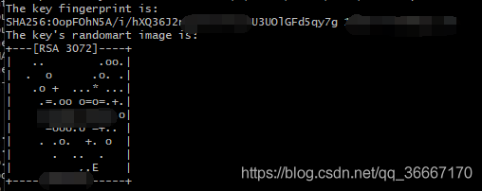  
当你看到上面这段代码，那就说明你的 SSH key 已经创建成功，你可以再使用~/.ssh看一下，现在文件是真的存在了。  
IMG_270

3.添加SSH Key到GitHub

首先打开Github网页  
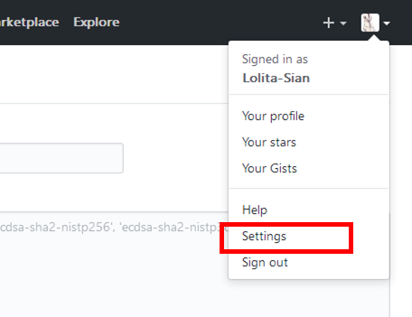  
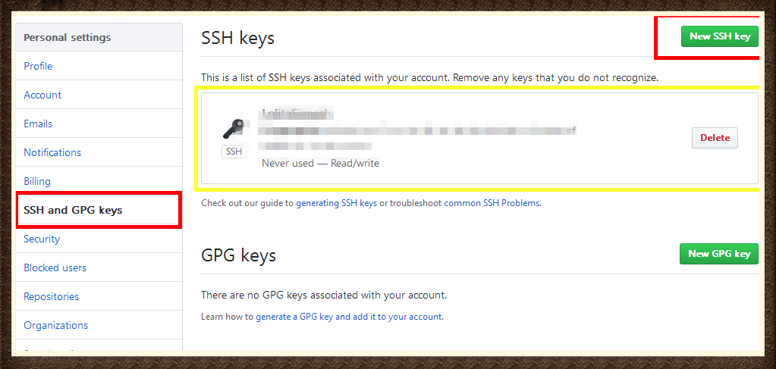  
（黄色框框是我已经建立的SSH key。）  
点击右上角新建一个SSH Key。  
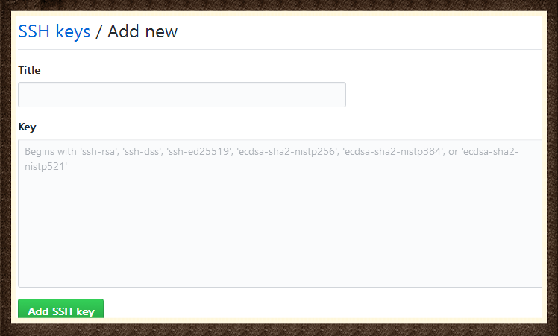  
title随便给他起个名字就好。然后是key，这时候你要打开你刚才在电脑上的SSH key。  
还记得这一步吗：  
IMG_274  
按照红框框里的路径，找到.ssh文件夹。用记事本打开id\_rsa.pub文件，全选其中的内容粘贴到网页的Key中。  
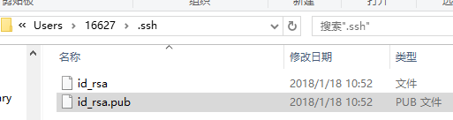

**然后你就会受到建立成功的邮件了。**  
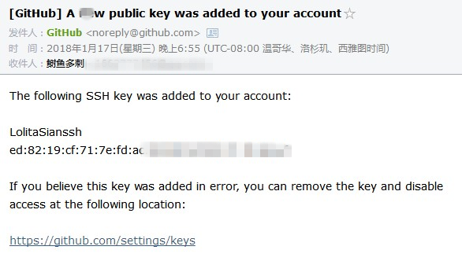

4.测试一下该SSH key

在git Bash 中输入以下代码  
$ ssh -T git@github.com  
**注意是git@github.com，不是你的邮箱。**

然后会提示你：  
**The authenticity of host ‘github.com (13.229.188.59)’ can’t be established.  
RSA key fingerprint is SHA256:nThbg6kXUp…**  
**Are you sure you want to continue connecting (yes/no/[fingerprint])?**  
输入yes，回车  
IMG_277

接下来就会提示你输入密码，如果上边设置ssh的时候，你没设置密码会提示你：  
**Warning: Permanently added ‘github.com,192.30.255.112’ (RSA) to the list of known hosts.**  
警告完了，如果你能看到如下提示，那你已经成功设置SSH密钥。  
**Hi “用户名”! You’ve successfully authenticated, but GitHub does not provide shell access.**  
如果你看到 **access denied**，者表示拒绝访问，那么你就需要使用 https 去访问。

[官方ssh帮助页面（英文版）](https://help.github.com/articles/connecting-to-github-with-ssh/)

我是萝莉安，是个小垃圾。